

Staff Report and Recommendation

Variance Case: LV-2025-01

Date of Report: January 10, 2025

Report by: Reid Turner, Planner Manager
Hearing Date: Wednesday, January 22, 2025

GENERAL INFORMATION
Applicant: Aztlan Engineering LLC
Owner: Iglesia Casa de Oracion Shalom
Size: 0.82 +/- Acre, District 6, Land Lot 147, Parcel 032
Location: 377 Hillcrest Rd, Lilburn, GA, 30047
Existing Zoning: CB, Commercial Business

EXISTING LAND USES & ZONING DISTRICTS
To the North: Commercial Business CB
To the East: Commercial Business CB
To the South: Commercial Business CB
To the West: Commercial Business CB

ZONING HISTORY
The subject site fronts Hillcrest Road, is surrounded by Commercial zoning, and is within the U.S. 29 Overlay District. According to city records, the subject site was initially zoned R-100 Single Family Residential according to the 2007 Official Zoning Map. Subsequently, the property was updated to the Commercial Retail land use in the cities Future Land Use Map, a component of the 2008 Comprehensive Plan Update. The property was proactively rezoned in 2008 to spur additional commercial development along U.S. 29. The property was never redeveloped to commercial standards, and the original residential home remained on the property until April of 2023.

The property was purchased in October of 2022 and in April of 2023 a Stop Work Order was placed on the property for construction without a permit. After a year of attempting to bring the property into compliance, the owner opted to demolish the structure and sell the property to the current applicant and property owner. The property has had no Variances, Special Use Permits, or Rezonings applied for or granted.

APPLICANT’S INTENT
The applicant is requesting a variance from the requirements of the Lilburn Code of Ordinances, Appendix A, Art. 8, § 812 - Minimum and maximum on-site parking spaces, to allow for the construction of a 4,950 square-foot religious assembly space. The Variance requested would reduce the total number of required spaces from 50 spaces to 25 spaces, a 50% reduction from standard parking requirements.

The Applicant met with staff multiple times to determine the pathway that accomplishes the city’s goals and ensures the success of the church. In discussing the proposal with the applicant, multiple options for Variances were proposed. Both staff and the applicant agree that the parking variance allows for the goals of the U.S. 29 Overlay District and the City as a whole to be accommodated while allowing for a development that functions for the intended use.

Additionally, to ensure that the reduced parking does not impact adjacent properties, the applicant is pursuing a shared parking agreement with the parcel next door in the event that the needs of the congregation grow beyond the scope of the proposed parking.

ANALYSIS OF VARIANCE REQUEST
Article 10. Section 1005. – Variances details the criteria to be considered when granting a variance, staff responses are below in red.
Variances will be considered only in the following cases:
- There are extraordinary and exceptional conditions or practical difficulties pertaining to the particular piece of property in question because of its size, shape or topography that are not applicable to other lands or structures in the same district. The orientation of the lot prohibits flexibility in building placement. A stormwater ditch bisects the lot prohibiting the placement of a structure in the middle of the lot. Further, the site/parking requirements of the U.S. 29 Overlay District prohibit the placement of parking lots in the front yards of parcels and incentivize building façade frontages along the ROW to provide for a more pedestrian-friendly relationship with the public space.
- A literal interpretation of the provisions of this Article would effectively deprive the applicant of rights commonly enjoyed by other properties of the district in which the property is located, resulting in unnecessary hardship. Granting this Variance allows the applicant to prioritize the size of the structure while providing the parking necessary for their specific use case.
- Such conditions are peculiar to the particular piece of property involved. The property is bisected by a Stormwater Ditch with an easement prohibiting building construction in this area.
- The special circumstances are not the result of any actions of the property owner. This Variance request is an effort to develop the site thoughtfully and is not a problem caused by the property owner.
- Granting the variance requested will not confer upon the property of the applicant any special privileges that are denied to other properties of the district in which the applicant's property is located. Granting the Variance request would allow the property to develop a building that serves their needs. No special privileges result from this, and the applicant is pursuing a shared parking agreement with the adjacent property to accommodate unmet parking demands.
- The requested variance will be in harmony with the purpose and intent of this Article and will not be injurious to the neighborhood or to the general welfare. A major goal of the City of Lilburn Comprehensive Plan is to create a pedestrian-oriented environment that encourages multi-modal transit options and reduces dependence on cars. Reducing parking minimums achieves the goals of City Leadership while ensuring that the relationship of the building to the public ROW encourages engagement and provides vegetation and screening desired by City Council.
- The variance requested is the minimum variance that will make possible the proposed use of the land, building, or structure in the zoning district in which the development is located. The applicant’s letter of intent correctly states that the Applicant is prioritizing landscaping and open space instead of parking to ensure the site is thoughtfully developed and contributes to the built environment in the City of Lilburn. This Variance request is the result of the applicant working with staff to determine the least injurious Variance possible to the City.

Based on the criteria for approval of a Variance, Staff recommends APPROVAL of the requested variance. Should the Zoning Board of Appeals decide to Approve the Variance request, staff recommends the following conditions:

- .There shall be no modifications granted for Water Quality or Runoff Reduction.
- The applicant shall be required to provide pedestrian access between the adjacent parcel (PIN 6147 033)
- The property owner shall provide the shared parking agreement to be retained within City Archives.
- The property shall be developed in accordance with the submitted site plan prepared by Aztlan Engineering dated 12/11/24.

GIS Aerial of Subject Site

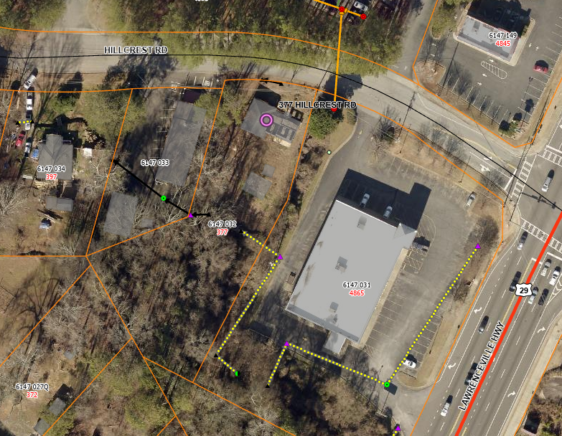
Subject Property

Official 2024 Zoning Map

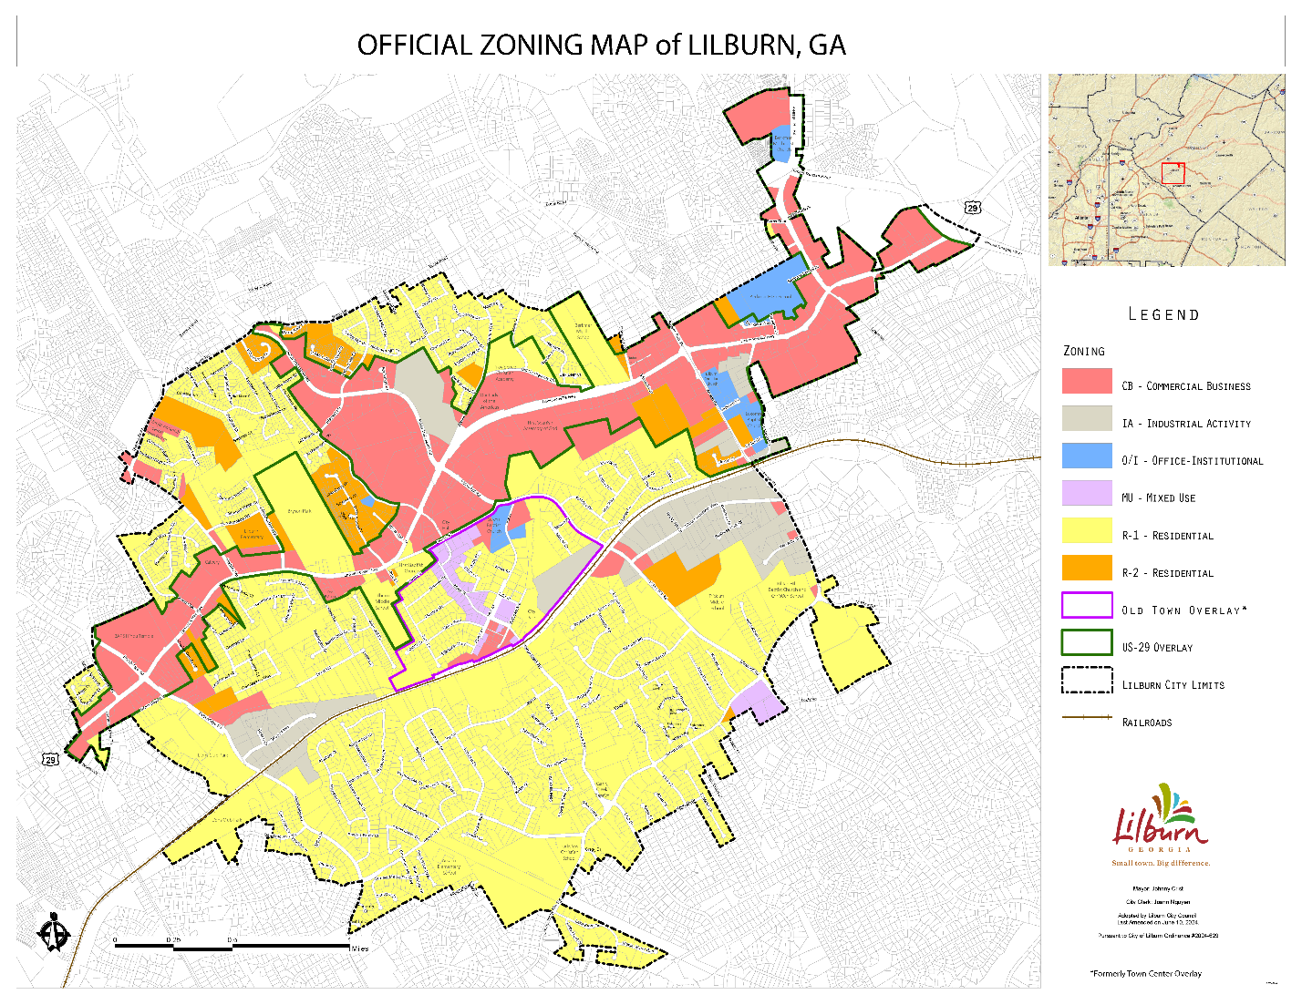
Subject Property

Official Zoning Map cont.

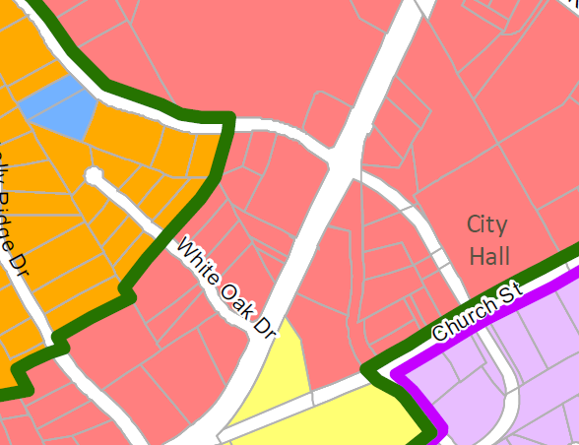
Subject Property
Subject Property
Site Plan for Subject Property with Proposed Garage